# **VBCS SCREEN - CWPS**

**Overview**

* CWK Timecard will be created into HCM-OTL and approved by Project Manager.
* Approved timecard will be imported into Project Accounting cost.
* By using BIP report, we fetched the details of timecard and invoice details.
* By using integration, we run the BIP report and generate the invoice.
* After invoice generation, VBCS application will show the timecard and invoice details.

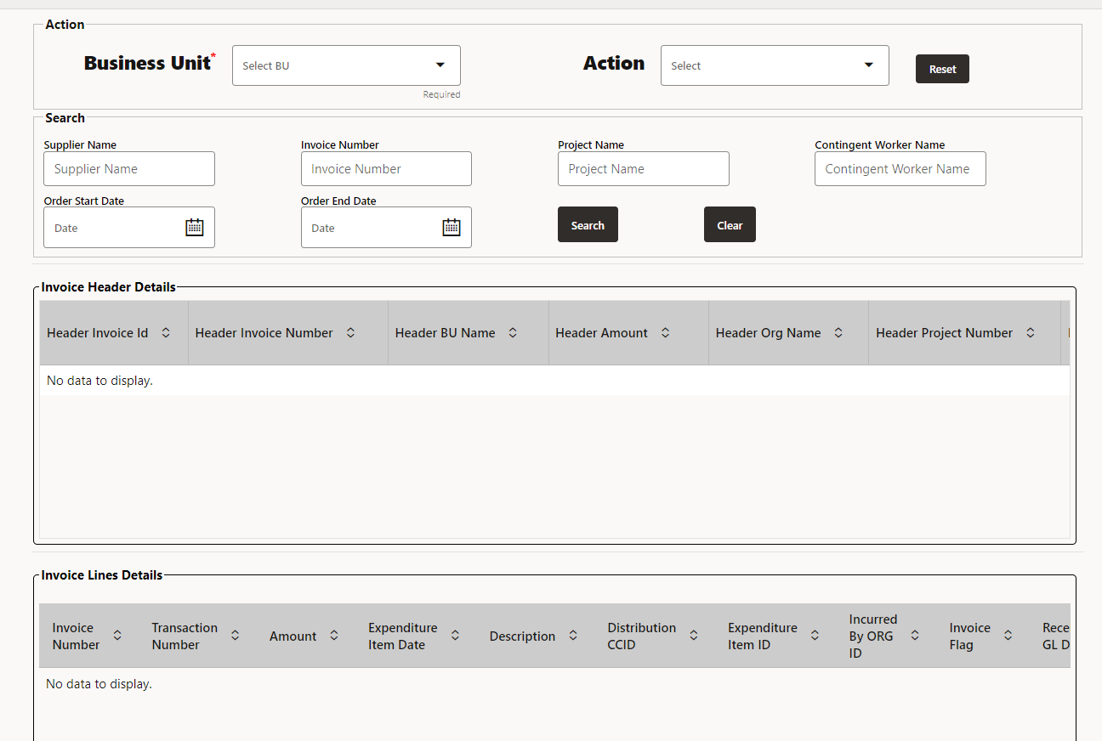

* We develop this screen to create invoice and display data.

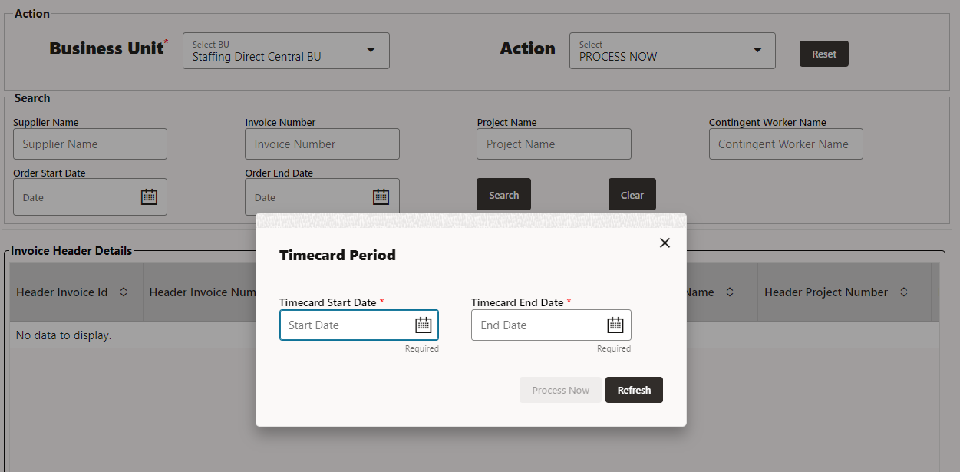

* Select Business Unit from drop down and select PROCESS NOW from Action drop down.
* After that Popup window will open. Provide timecard start Date and timecard End Date that is mandatory. Timecard start Date and Timecard End Date is the date for that invoice will be created, if timecard is approved for that date.
* If user enter same date again then invoice will not be created, it gives error ”Duplicate Dates cannot create invoice”.
* After giving Timecard start date and timecard end date click on Process Now button, then invoice will be generated.
* After that click on Refresh Button to load the data from ATP database to VBCS screen.

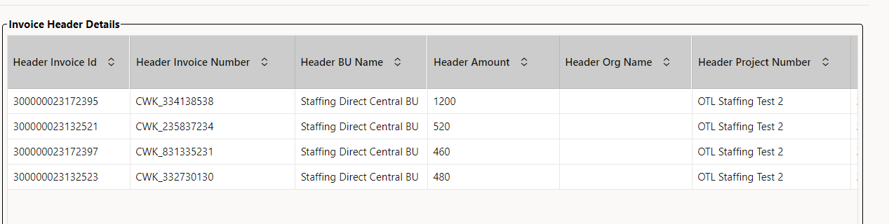

* Once the invoice is created successfully then the employee timecard information for which the invoice is created along with invoice number and other details are displayed on the Screen.
* Click on row of invoice header to get the Invoice lines detail related to invoice header details.

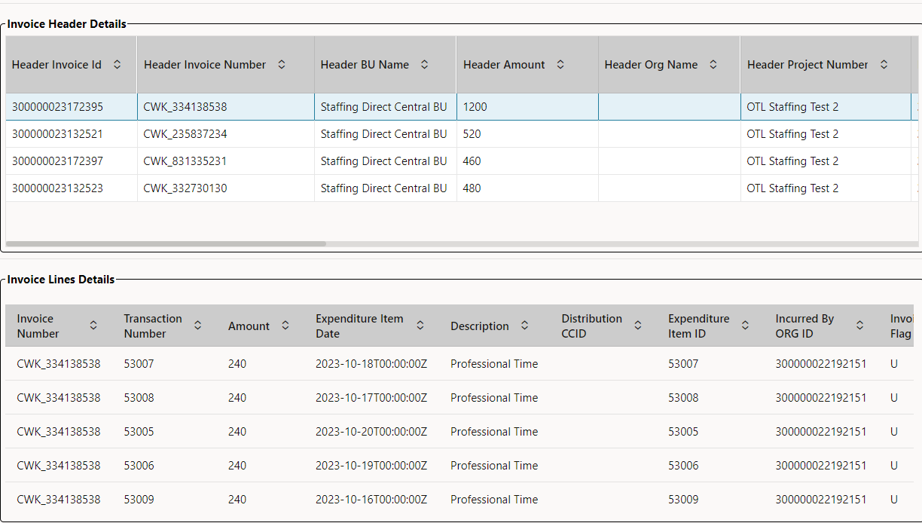

* Search page is capable of bring all employee and invoice details of contingent worker timecard details.
* For Search the specific data provide the required input and click on **Search** button.

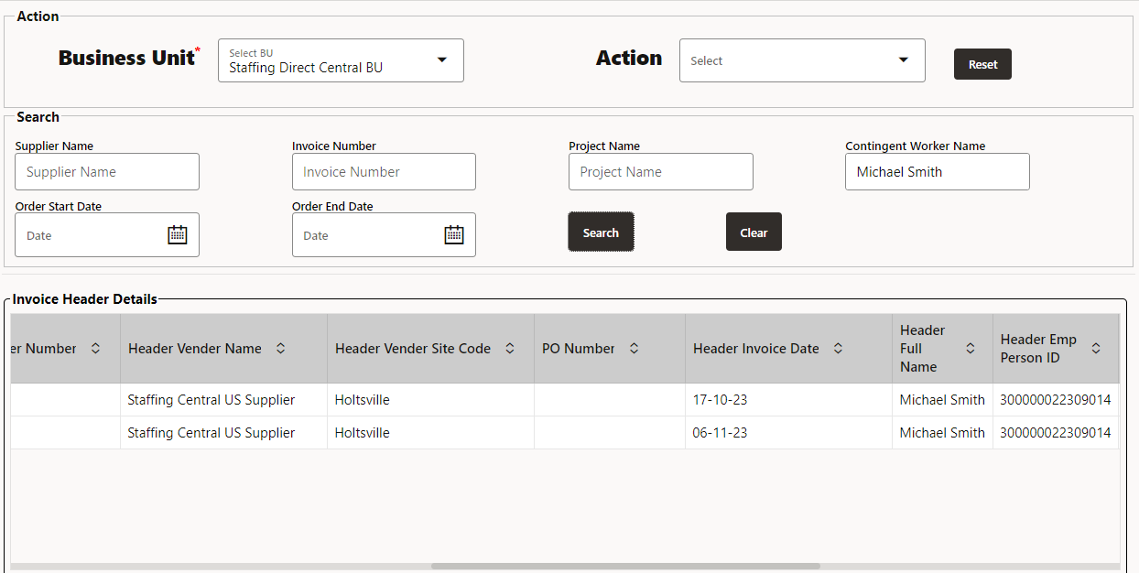

* We get the required data.

**GUI Column Details:**

* Business Unit: Business Unit in which the invoice is created.
* Contingent Name: Contingent employee name
* Project Number: Project number where the contingent worker costs are incurred.
* Supplier Name: Supplier name for which the invoice is created.
* Supplier Site: Supplier site details of the invoice
* Expenditure Type: Expenditure type of which the contingent worker cost is incurred (Eg : Professional Hours, Overtime etc.)
* Quantity: Quantity in Hours filled in timecard for the contingent worker
* Invoice Date: Date on which the Invoice is created.
* Invoice Number: Invoice Number details
* Invoice Currency: Currency code for the invoice
* Invoice Amount: Cost amount incurred for contingent worker based on expenditure type and quantity.
* Timecard Date: Date on which the timecard is entered for the contingent worker.

Below Are the ATP tables used in Invoice creation:

XXCG_CWK_INVOICE_HEADER

XXCG_CWK_INVOICE_LINES

CHECK_VALIDATION_FLAG